**Preface**

Thank you for your interest in *Professional Responsibility: An Open-Access Casebook*. We hope that you find it useful and informative.

This is a free casebook. We believe that law students and others interested in the law should not have to pay the high prices that commercial publishers charge for casebooks. Many others agree, and have created free or low-cost casebooks covering many different areas of the law. Here are some examples:

| **Practice Area** | **Casebook** |
| --- | --- |
| Advertising and Marketing | [Eric Goldman](https://www.ericgoldman.org/) & [Rebecca Tushnet](https://hls.harvard.edu/faculty/directory/11412/Tushnet), [*Advertising & Marketing Law: Cases & Materials*](https://blog.ericgoldman.org/archives/2019/01/announcing-the-fourth-edition-of-advertising-marketing-law-cases-materials-by-tushnet-goldman-2.htm) |
| Civil Rights | [John T. Parry](https://law.lclark.edu/live/profiles/269-john-parry), [*Cases and Problems in Civil Rights Litigation: State, Federal and International Perspectives*](https://www.semaphorepress.com/CivilRightsLitigationOverview.html) |
| Intellectual Property | [James Boyle](https://law.duke.edu/fac/boyle/) & [Jennifer Jenkins](https://law.duke.edu/fac/jenkins/), [*Open Intellectual Property Casebook*](https://law.duke.edu/cspd/openip/) |
| Intellectual Property | [James Grimmelmann](https://james.grimmelmann.net/ipbook/), [*Patterns of Information Law: Intellectual Property Done Right*](https://james.grimmelmann.net/ipbook/) |
| Intellectual Property | [Lydia Pallas Loren](https://law.lclark.edu/live/profiles/293-lydia-loren) & [Joseph Scott Miller](http://www.law.uga.edu/profile/joseph-s-miller), [*Intellectual Property Law: Cases & Materials*](https://www.semaphorepress.com/IntellectualPropertyLaw_overview.html) |
| Internet Law | [James Grimmelmann](http://james.grimmelmann.net/), [*Internet Law: Cases and Problems*](http://internetcasebook.com/) |
| Interstate Law | [Jeffrey Litwak](https://law.lclark.edu/live/profiles/2860-jeff-litwak), [*Interstate Compact Law: Cases & Materials*](https://www.semaphorepress.com/InterstateCompactLaw_overview.html) |
| Property | [Stephen Clowney](https://law.uark.edu/directory/directory-faculty/uid/sclowney/name/Steve+Clowney/), [James Grimmelmann](https://james.grimmelmann.net/), [Michael Grynberg](https://law.depaul.edu/faculty-and-staff/faculty-a-z/Pages/michael-grynberg.aspx), [Jeremy Sheff](https://www.stjohns.edu/academics/bio/jeremy-sheff) & [Rebecca Tushnet](https://hls.harvard.edu/faculty/directory/11412/Tushnet), [*Open Source Property: A Free Casebook*](https://opensourceproperty.org/) |
| Property | [Steve Semeraro](https://www.tjsl.edu/directory/steven-semeraro), [*An Introduction to Property Law in the U.S.*](https://www.semaphorepress.com/PropertyLaw_overview.html) |
| Trademark | [Barton Beebe](https://its.law.nyu.edu/facultyprofiles/index.cfm?fuseaction=profile.overview&personid=30077), [*Trademark Law: An Open-Source Casebook*](http://tmcasebook.org/) |

In addition, the [Center for Computer-Assisted Legal Instruction (CALI)](https://www.cali.org/) offers [free casebooks](https://www.cali.org/collections/casebook) in many different subjects, including:

* Bankruptcy Law and Practice
* Basic Income Tax
* Contract Doctrine, Theory & Practice
* Corporate Income Tax
* The Ethics of Tax Lawyering
* First Amendment: Cases, Controversies, and Contexts
* Land Use
* The Law of Trusts
* Law of Wills
* Property
* Sales and Leases: A Problem-based Approach
* Selected Materials on the Law of Evidence
* Sources of American Law: An Introduction to Legal Research
* The Story of Contract Law
* Torts: Cases and Contexts
* U.S. Federal Income Taxation of Individuals
* Wetlands Law: A Course Source

We noticed that there was no free and open-source casebook available for a professional responsibility class, so we decided to create one.

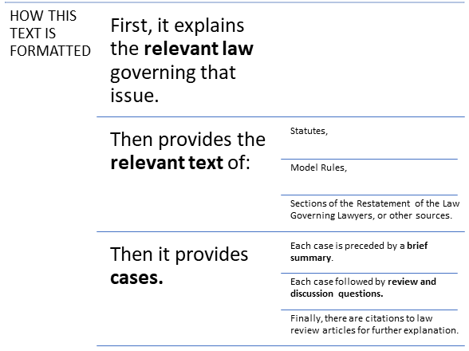

This casebook covers a wide range of different subjects related to the professional responsibility of attorneys. While it is possible to cover all of this material in a three credit-hour course, you may wish to omit some subjects. You may also wish to supplement the materials in this casebook with additional materials. We encourage you to use this casebook in any way that you like.

This casebook is licensed “Creative Commons 0 / No Rights Reserved.” That means that we explicitly disclaim any copyright claim in all of the original elements that we created in writing this casebook and have intentionally placed the casebook in the public domain. Because this casebook is in the public domain, you can use the materials in it in any way that you like, with or without attribution. Of course, the casebook contains many copyrighted elements that belong to other people and that we used pursuant to fair use. Those elements are still protected by copyright.

We hope that this free casebook helps show that it is possible to create teaching materials for legal education in an open-source format. And we hope it makes access to the law governing legal practice more accessible to law students, attorneys, and anyone interested in the regulation of the legal profession.

In closing, we would like to thank our research assistants Nicole Pottinger, Justin Cloyd, Mark Blankenship, Barrett Block, and Renee Wilson. We would also like to thank Cornelius Kearns, Brandon Magner, and Guy Hamilton-Smith for helpful comments.

* [Brian L. Frye](http://law.uky.edu/directory/brian-l-frye)  
  [Elizabeth Schiller](https://law.richmond.edu/faculty/eschille/)  
  S.J. Morrison